### Speed Detector

### A Mini Project-II Report

# *Submitted in Partial Fulfillment of the Requirements*

# *for the Degree of*

**Bachelor Of Technology**

## in

## ELECTRONICS & COMMUNICATION ENGINEERING

### By By

Meet Mehta Parth Modi

16bec087 16bec092

Under the Guidance of

Prof. Rutul Patel



### Department of Electronics & Communication Engineering

### Institute of Technology, Nirma University

### Ahmedabad-382481

### May 2018

**CERTIFICATE**

This is to certify that the Mini Project-II Report entitled **“Speed Detector”** submitted by **Meet Mehta (**Roll No. **16BEC087) and Parth Modi (**Roll No. **16BEC092)** as the partial fulfillment of the requirements for the award of the degree of Bachelor of Technology in Electronics &Communication Engineering, Institute of Technology, Nirma University is the record of work carried out by them under my supervision and guidance. The work submitted in our opinion has reached a level required for being accepted for the examination.

**Date: 2nd May, 2019**

# Prof. Rutul Patel

# Project Guide

**Prof. (Dr.) D. K. Kothari**

**HOD (EC)**

**Acknowledgement**

We would like to express our deepest appreciation to all those who provided us the possibility to complete this report.  A special gratitude we give to our final year project guide, [Prof. Rutul Patel] whose contribution in stimulating suggestions and encouragement and investing his full effort in guiding us to achieve our targets.

Furthermore we would also like to acknowledge with much appreciation the crucial role of the staff of [Vaibhavi ma’am], who gave the permission to use all required equipment and the necessary materials to complete the task. Many thanks. We have to appreciate the guidance given by other supervisor [Prof. Dhaval Shah] especially in our project presentation that has improved our presentation skills thanks to their comment and advices.

**ABSTRACT**

Many people lose their lives due to irresponsible driving and over-speeding. The police and the government have made many efforts to reduce the number of accidents taking place due to over-speeding. This project utilizes a simple and inexpensive method of detecting the speed of a moving vehicle on a road. The module that is developed from this project can be installed on the roads and if the module detects an over-speeding vehicle then information about that vehicle can be sent to the officials for further investigation.Index

|  |  |  |  |  |  |
| --- | --- | --- | --- | --- | --- |
| **Chapter No.** | Title | | | **Page No.** | |
|  | Acknowledgement | | | **i** | |
|  | Abstract | | | **ii** | |
|  | Index | | | **iii** | |
|  | List of Figures | | | **iv** | |
| **1** | Introduction | | |  | |
|  | 1.1 | | Introduction | | 1 | |
|  | 1.2 | | Scope | | 1 | |
|  | 1.3 | | Objective | | 1 | |
|  | 1.4 | | Contents of the report | | 2 | |
| **2** | Components Required | | | |  |
|  | 2.1 | | Component List | | 2 | |
|  | 2.2 | | Arduino MEGA | | 2 | |
|  | 2.3 | | IR Sensor Modules | | 3 | |
|  | 2.4 | | LCD Screen | | 4 | |
| **3** | **Working** | | | |  | |
|  | 3.1 | | Working | | 5 | |
|  | 3.2 | | Flowchart | | 7 | |
| **4** | **Results** | | |  | |
| 4.1 | Initial Condition | | 8 | | |
| 4.2 | After normal speed detection | | 9 | | |
| 4.3 | Over-speed Detection | | 9 | | |
|  | **Conclusions** | | | 9 | | |
|  | **Appendix** | | | 10 | | |
|  | **References** | | | 14 | | |

**LIST OF FIGURES**

|  |  |  |
| --- | --- | --- |
| **Fig. No.** | **Title** | **Page No.** |
| 1 | Arduino MEGA pin distribution | 3 |
| 2 | IR sensor module circuit diagram | 4 |
| 3 | LCD module | 4 |
| 4 | Schematic Diagram | 5 |
| 5 | Image of model | 6 |
| 6 | Flowchart | 7 |
| 7 | Model at initial condition | 8 |
| 8 | After normal speed detection | 9 |
| 9 | Over-speed Detected | 9 |

**Chapter 1**

**Introduction**

The speed detector that is designed under this project is housed with two IR sensors and an Arduino MEGA. The speed of the vehicle is displayed on a LCD display. This module is capable of detecting the speed of a vehicle very accurately. The scenario of over-speeding takes place when the speed of the passing vehicle is more than the speed limit of that road. Arduino determines whether ober-speeding is detected or not.

**Objective**

The objective of the project is to calculate the speed of a vehicle crossing the module designed under this project and display the calculated speed on an LCD screen. Also, check if the vehicle was over-speeding or not. Infrared sensors are to be used as motion detectors that will help sense the speed of the vehicles crossing the module. Arduino is provided and is used to calculate the speed of the vehicle depending upon the signals that will be provided by the IR sensors.

**Scope**

The project on completion will be able to calculate the speed of any vehicle travelling at a speed between 0-6 km/hr. The upper limit of the detectable speed is very low because of the limitation caused by the Infrared sensors. The Infrared sensors are incapable of detecting motion at speed greater than above mentioned. Speed of vehicles travelling in any direction in front of the module can be detected. The module does even identify if the vehicle is over-speeding or not. The limitations of the project are that it cannot detect speeds greater than 6 km/hr and also that it provides wrong value of speed if two or more vehicles simultaneously pass in front of the module.

**Contents of the report**

* The list of components used is provided with brief information about all the components.
* Working of the project is explained.
* The flowchart of the code is provided that can be easily understood.
* The results generated by the trial run of the model are published.
* The code is provided in the appendix for reference.

**Chapter 2**

**Component List**

In making this project the components used by us include:

1. Arduino MEGA
2. IR Sensor Module
3. LCD Display

**Arduino MEGA**

Arduino MEGA 2560 is a microcontroller board based on Atmega 2560 microcontroller. Arduino Boards have revitalized the automation industry with their easy to use platform where everyone with little or no technical background can get started with learning some basic skills to program and run the board [1].

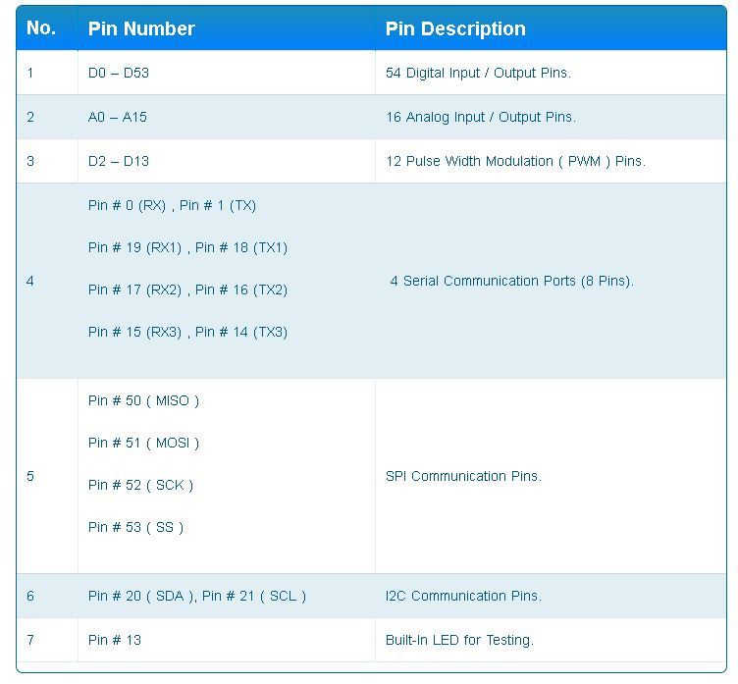

Figure 1: Arduino MEGA pin distribution [1]

**IR Sensor Module**

An infrared sensor is an electronic device that emits in order to sense some aspects of the surroundings. An IR sensor can measure the heat of an object as well as detects the motion. These types of sensors measures only infrared radiation, rather than emitting it that is called as a passive IR sensor. Usually in the infrared spectrum, all the objects radiate some form of thermal radiations. These types of radiations are invisible to our eyes that can be detected by an infrared sensor. The emitter is simply an IR LED (Light Emitting Diode) and the detector is simply an IR photodiode which is sensitive to IR light of the same wavelength as that emitted by the IR LED. When IR light falls on the photodiode, the resistances and these output voltages, change in proportion to the magnitude of the IR light received.

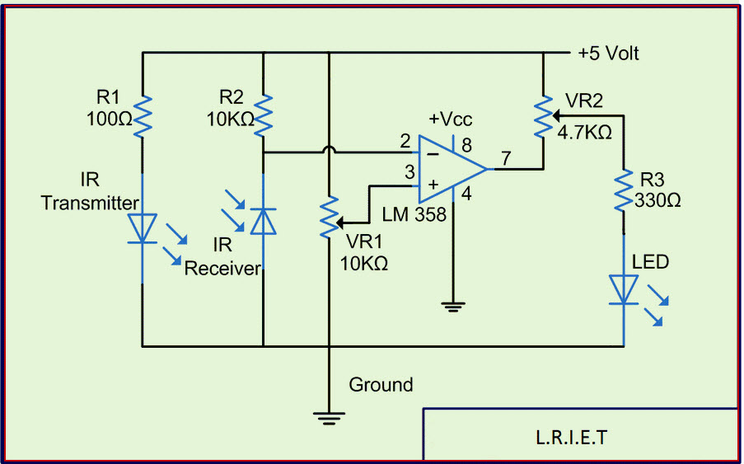

Figure 2: IR Sensor Module circuit diagram

An infrared sensor circuit is one of the basic and popular sensor modules in an electronic device. This sensor is analogous to human’s visionary senses, which can be used to detect obstacles and it is one of the common applications in real time. This circuit comprises of the above components [2].

**LCD Module**

LCD (Liquid Crystal Display) screen is an electronic display module and find a wide range of applications. A 16x2 LCD display is very basic module and is very commonly used in various devices and circuits. These modules are preferred over seven segments and other multi segment LEDs. The reasons being: LCDs are economical; easily programmable; have no limitation of displaying special & even custom characters (unlike in seven segments), animations and so on.

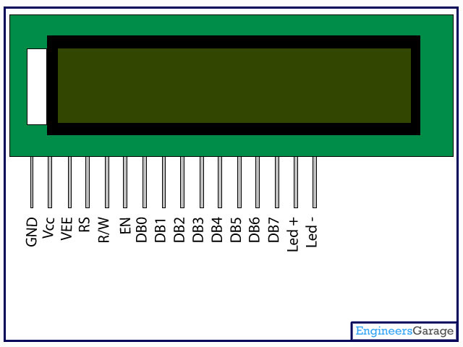

Figure 3: LCD module

A 16x2 LCD means it can display 16 characters per line and there are 2 such lines. In this LCD each character is displayed in 5x7 pixel matrix. This LCD has two registers, namely, Command and Data.

The command register stores the command instructions given to the LCD. A command is an instruction given to LCD to do a predefined task like initializing it, clearing its screen, setting the cursor position, controlling display etc. The data register stores the data to be displayed on the LCD. The data is the ASCII value of the character to be displayed on the LCD. Click to learn more about internal structure of a LCD [3].

**Chapter 3**

**Working**

As soon as one of the IR sensor module is crossed by a moving vehicle then the resistance of the IR sensor increases. This change of resistance in the IR sensor changes the amount of current flowing in the circuit. This change in the current is sensed by the Arduino and as per the code that is fed into the Arduino when the magnitude of current flowing in the circuit crosses a certain limit the Arduino defines this condition as IR sensor input to be ‘0’. When the above condition is fulfilled Arduino starts the counter which increments every millisecond until the other IR sensor is crossed by the passing vehicle.

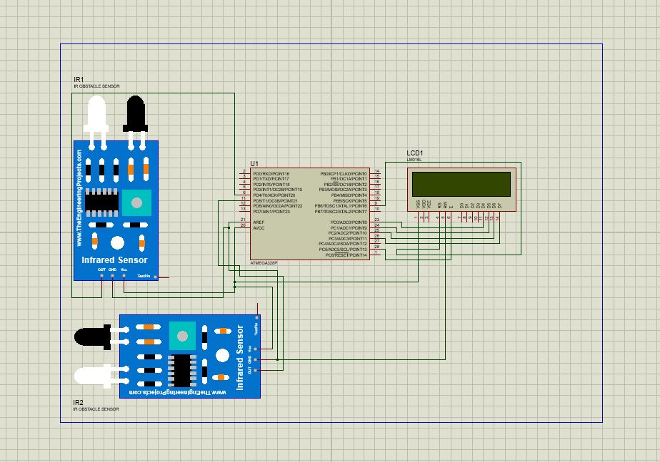

Figure 4: Schematic Diagram

As soon as the other IR sensor gives an output ‘0’ to the Arduino, the Arduino stops the counter. The value of the counter is the time taken by the vehicle to cross the fixed distance between the IR sensors.

Now as we know the distance travelled by the vehicle and the time taken by the vehicle to cross that distance, we can easily calculate the speed of the vehicle as:

Speed = Distance/Time.

The distance is taken as 30 cm or 0.3 m.

So the formula turns out to be:

s = (60000.0*0.3/count)

Here, count is the time calculated by the Arduino and 60,000 is the multiplying factor which helps

convert milliseconds into seconds. The unit of s is m/s. to convert it to km/hr we use the formula:

h = 3.6*s.

Hence h is the final quantity which is required in the project.

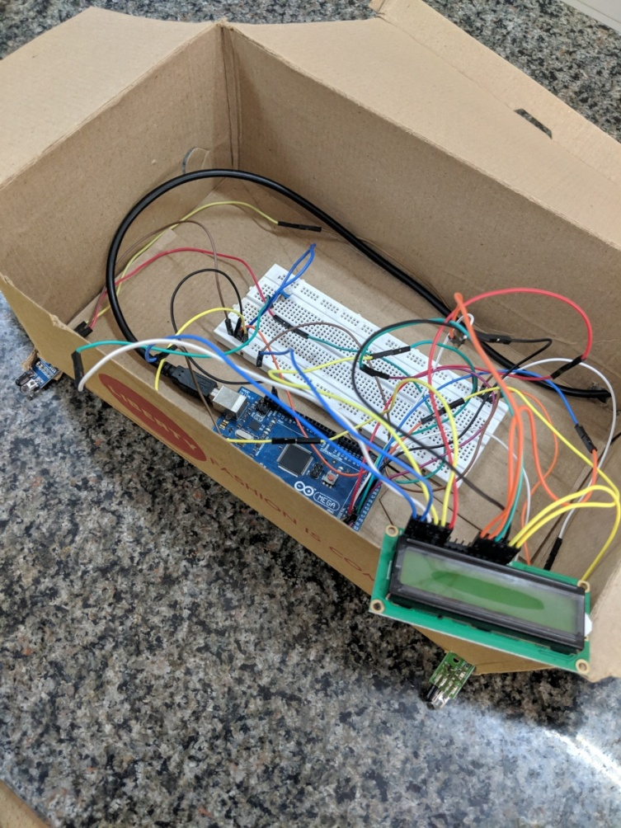

Figure 5: Image of Model

**Flowchart**

Figure 6: Flowchart

**Chapter 4**

**Results**

**Initial Condition**

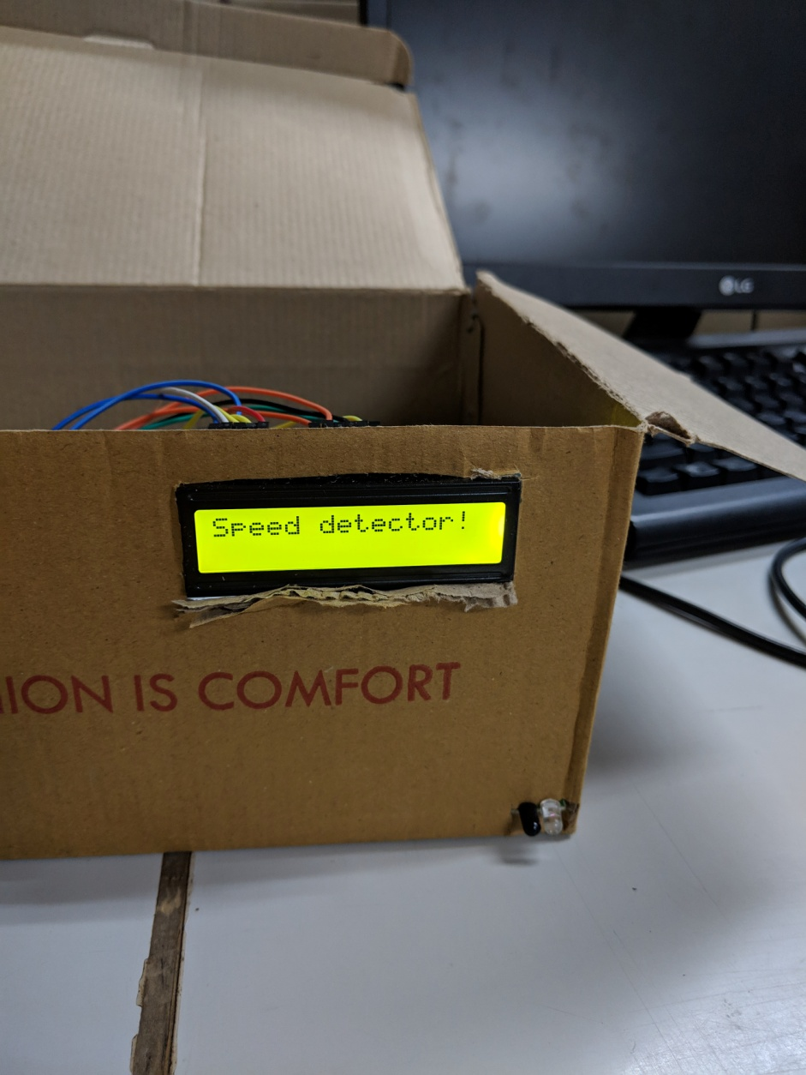

Figure 7: Model at initial condition

**After Normal Speed Detection**

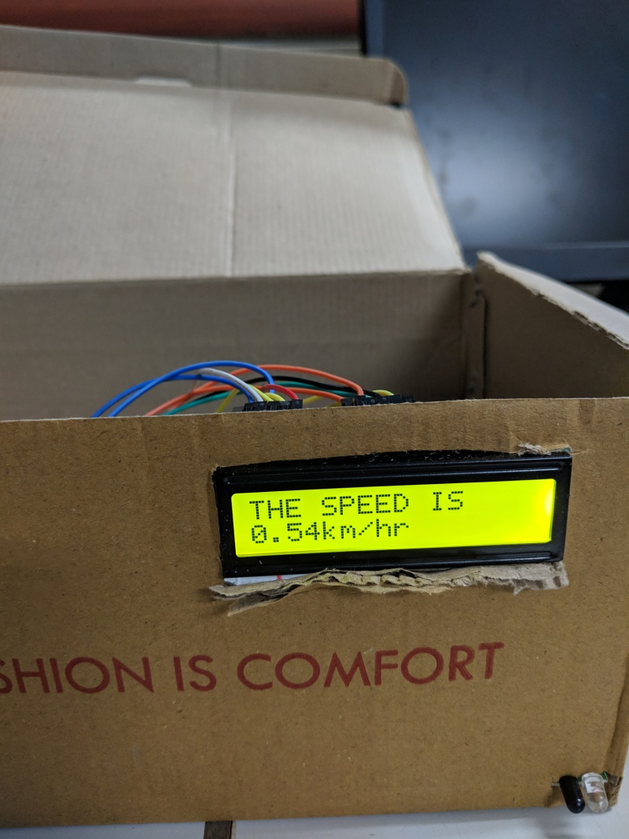

Figure 8: After normal speed detection

**Over-speed Detection**

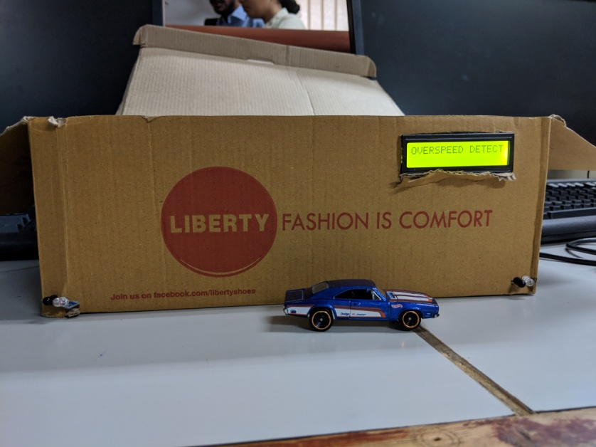

Figure 9: Over-speed Detected

**Conclusion**

The objective of speed detection of the project was successfully accomplished by us. From this project we learnt and practice interfacing of sensors with an Arduino microcontroller and also interfacing of LCD screen with the Arduino. Complete setup of the proposed module was created by us and was tested and was found to be in working condition. After implementing the given problem statement using two IR sensors as motion detectors we found some limitations of the same. One of the limitations of using IR sensors is that it cannot detect motion at realistic speeds of about 30km/hr as it is incapable of measuring motion at such speeds. Also, the distance range of these sensors is not very high. Another limitation caused by both IR sensors and LCD screen is that, the speed of only one vehicle can be measured at a time using this module and if more than one vehicle cross the modue at the same time then the module gives out ambiguous values.

**Appendix**

**Code**

//SPEED DETECTOR

#include <TimeLib.h>

#include <LiquidCrystal.h>

const int IR_Sensor1 = 35;

const int IR_Sensor2 = 34;

LiquidCrystal lcd(53, 52, 50, 48,46,44);

void setup() {

pinMode(IR_Sensor1, INPUT);

pinMode(IR_Sensor2, INPUT);

Serial.begin(9600);

lcd.begin(16, 2);

lcd.print("hello, world!");

}

float next = 0, count = 0;

void loop()

{

float h, h1, t, s;

delay(5);

//lcd.clear();

if (digitalRead(IR_Sensor1) == 0)

{

count = 0;

next = 0;

while (!next)

{

delayMicroseconds(1);

count++;

if (digitalRead(IR_Sensor2) == 0)

{

lcd.clear();

next = 1;

Serial.print("The time taken to reach from point A to point B is ");

Serial.print(count/60000.00);

Serial.print(" seconds ");

Serial.println();

float s=(60000.0*0.3/count);

Serial.print("The speed is");

Serial.print(s,2);

Serial.print("m/s");

Serial.println();

h=3.6*s;

Serial.print("The speed in km/hr is : ");

Serial.print(h,2);

Serial.println();

lcd.setCursor(0,0);

delay(500);

lcd.print("THE SPEED IS ");

delay(500);

lcd.setCursor(0,1);

delay(500);

lcd.print(h,2);

delay(500);

lcd.print(" km/hr");

delay(500);

digitalWrite(IR_Sensor1, HIGH);

digitalWrite(IR_Sensor2, HIGH);

if(h>=1)

{

Serial.println("Overspeed Detected ");

delay(500);

lcd.clear();

lcd.print("OVERSPEED DETECTED");

delay(500);

// lcd.clear();

}

}

}

}

next = 0;

if (digitalRead(IR_Sensor2) == 0)

{

count = 0;

next = 0;

while (!next)

{

delayMicroseconds(1);

count++;

if (digitalRead(IR_Sensor1) == 0)

{

lcd.clear();

next = 1;

Serial.print("The time taken to reach from point B to point A is ");

Serial.print(count/60000.00);

Serial.print(" seconds ");

Serial.println();

float s=(60000.0*0.3/count);

Serial.print("The speed is");

Serial.print(s,2);

Serial.print("m/s");

lcd.setCursor(0,0);

lcd.print("THE SPEED IS ");

delay(1000);

lcd.setCursor(0,1);

lcd.print(h,2);

delay(1000);

lcd.print("km/hr");

delay(1000);

//delay(1000);

Serial.println();

h=3.6*s;

Serial.print("The speed in km/hr is : ");

Serial.print(h,2);

Serial.println();

digitalWrite(IR_Sensor1 , HIGH);

digitalWrite(IR_Sensor2, HIGH);

if(h>=1)

{

Serial.println("Overspeed Detected ");

lcd.clear();

delay(500);

lcd.print("OVERSPEED DETECTED");

delay(500);

}

}

}

}

next = 0;

}

References

1. Aqeel, A. (2019). *Introduction to Arduino Mega 2560 - The Engineering Projects*. [online] The Engineering Projects. Available at: https://www.theengineeringprojects.com/2018/06/introduction-to-arduino-mega-2560.html [Accessed 2 May 2019].
2. ElProCus - Electronic Projects for Engineering Students. (2019). *IR Sensor Circuit and Working with Applications*. [online] Available at: https://www.elprocus.com/infrared-ir-sensor-circuit-and-working/ [Accessed 2 May 2019].
3. Engineersgarage.com. (2019). *16 x 2 LCD Datasheet | 16x2 Character LCD Module PINOUT*. [online] Available at: https://www.engineersgarage.com/electronic-components/16x2-lcd-module-datasheet [Accessed 2 May 2019].